Jan2018

Firm Name & Logo

| **Sun** | **mon** | **tue** | **wed** | **thu** | **fri** | **sat** |
| --- | --- | --- | --- | --- | --- | --- |
|  | 01 | 02 | 03 | 04 | 05 | 06 |
|  |  |  |  |  |  |  |
| 07 | 08 | 09 | 10 | 11 | 12  **Join us for your favorite drink and get energized for busy season!** | 13 |
|  |  |  |  |  | **Kickoff**  **Happy Hour** |  |
| 14 | 15 | 16 | 17 | 18 | 19 | 20 |
|  |  | **Pancake Breakfast** |  |  | **Tax Season**  **Officially**  **Begins** |  |
| 21 | 22 | 23 | 24 | 25 | 26 | 27 |
| **Fuel up with healthy snacks!** |  |  |  | **College**  **Show your school spirit and come to the office decked out in your alma mater’s swag!**  **Gear**  **Day** |  |  |
| 28 | 29 | 30 | 31 |  |  |  |
|  |  | **Musical**  **Chairs**  **Competition** |  |  |  |  |

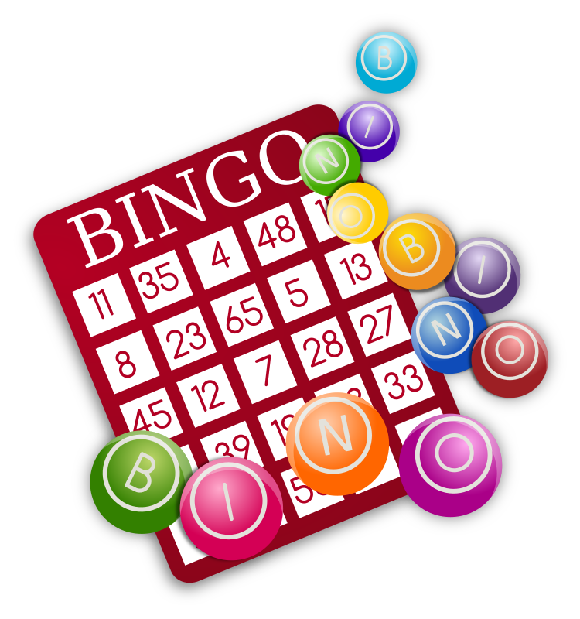Feb2018

Firm Name & Logo

| **Sun** | **mon** | **tue** | **wed** | **thu** | **fri** | **sat** |
| --- | --- | --- | --- | --- | --- | --- |
|  |  |  |  | 01 | 02 | 03 |
|  |  |  |  |  | **Employee**  **Appreciation Day** |  |
| 04 | 05 | 06 | 07 | 08 | 09 | 10 |
| Image result for super bowl 2018 logo |  | **We challenge you to make at least one meeting an active one today!**  **Walking Meeting** |  |  |  |  |
| 11 | 12 | 13 | 14  **Bring your favorite bowl from home, we are hosting a soup & chili lunch buffet!** | 15 | 16 | 17 |
|  | **Represent your team by sporting your favorite gear!**  **Favorite Sports Team Day** |  | **Heart**  **To**  **Heart** |  |  |  |
| 18 | 19 | 20 | 21  **One minute on the clock to make the best sentence from candy conversation hearts!** | 22  **Thanks for all your hard work! Join us for lunch out of the office!** | 23  **Happy Friday! Grab a delicious cupcake after lunch today!** | 24 |
| Image result for all star game 2018 |  |  | ***“Whoa, We’re Halfway There!”*** |  |  | **Hat Day** |
| 25 | 26 | 27 | 28 |  |  |  |
|  |  | **Electronic Bingo**  **A new spin on Bingo! Check your email for a digital bingo card every half hour.** |  |  |  |  |

Mar2018

Firm Name & Logo

**Eggs hidden around the office will contain all sorts of goodies!**

| **Sun** | **mon** | **tue** | **wed** | **thu** | **fri** | **sat** |
| --- | --- | --- | --- | --- | --- | --- |
|  |  |  |  | 01 | 02 | 03 |
|  |  |  |  |  | **Massage Therapist**  **A favorite activity from last year is back again!** |  |
| 04 | 05 | 06 | 07 | 08 | 09 | 10 |
|  |  |  |  | **Guess closest to the actual number of candies in the jar and win the lot!**  **Bean Counter** |  | **Work from**  **Home** |
| 11 | 12 | 13 | 14 | 15  **Grab your laptop and your bracket for a working watch party!** | 16 | 17 |
|  | **Silent Disco**  **Put your headphones on, crank up the tunes and let’s dance it out!** |  |  |  |  |  |
| 18 | 19 | 20 | 21 | 22 | 23 | 24 |
|  |  |  |  | **Omelet**  **Bar** |  |  |
| 25 | 26 | 27 | 28 | 29 | 30 | 31 |
|  |  | **Yoga in the Conference Room** |  |  | **Office Egg Hunt** |  |

Apr2018

Firm Name & Logo

| **Sun** | **mon** | **tue** | **wed** | **thu** | **fri** | **sat** |
| --- | --- | --- | --- | --- | --- | --- |
| 01 | 02 | 03 | 04 | 05 | 06 | 07 |
|  |  | **Pizza Party Lunch** |  | **Firm**  **Show our team spirit by wearing your favorite firm logo items!**  **Logo**  **Day** |  | **Crazy Sock Day** |
| 08 | 09  **Who will be**  **the champion of our own basketball tournament?** | 10 | 11 | 12 | 13 | 14 |
|  | **Ice**  **Cream**  **Sundaes** |  |  |  | **Cornhole Tournament**  **Take a break this Friday & participate in a game of cornhole!** |  |
| 15 | 16 | 17 | 18 | 19 | 20 | 21 |
|  |  |  | **Office Closure**  **You deserve it!** |  |  |  |
| 22 | 23 | 24 | 25 | 26 | 27 | 28 |
|  |  |  |  |  |  |  |
| 29 | 30 |  |  |  |  |  |
|  |  |  |  |  |  |  |